MACH4METAL

metalworking machinery
Transito 21, 6909 DA Babberich, Netherlands
Tel. + 31 (0)316 – 247123
Fax. + 31 (0)316 - 247956
info@mach4metal.com
www.mach4metal.com
Bank No : 66.52.13.883
IBAN : NL33 INGB 0665 2138 83
BIC : INGBNL2A
VAT : NL 815393635B01

EST Ticino ET - BM - MC 420 / 1500
sliding bed universal lathe

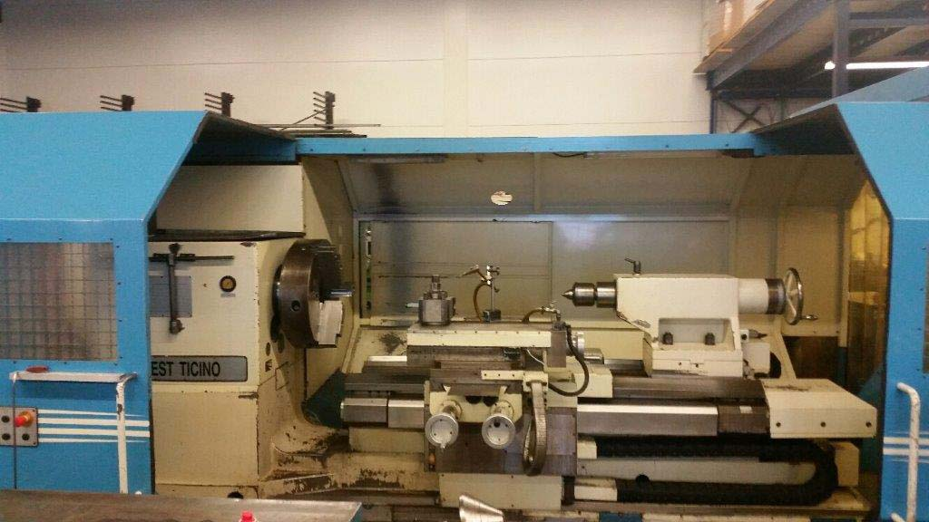
- Make : EST Ticino ITALIA
- Typ : ET-BM-MC 420 / 1.500
- Age : 2001
- Mach.No : 0012..

- Swing over bed : 840
- Swing over support : 510
- Swing in the gap : 1.580
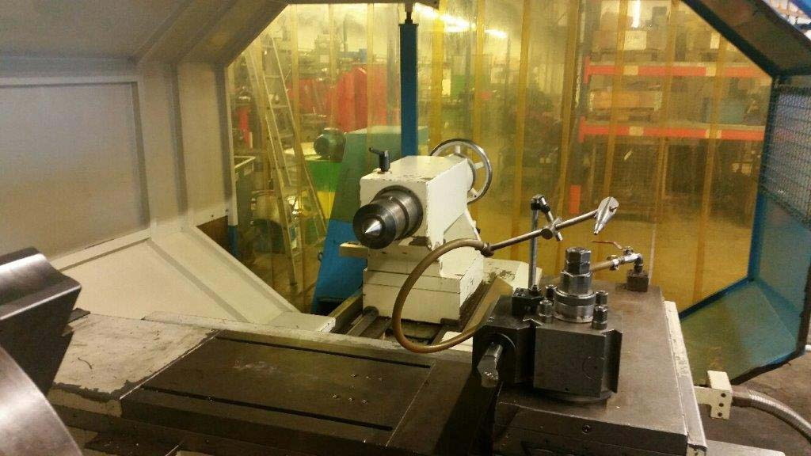
- Centre distance : 1.500
- Gap length : 500
- Centre distance bed open : 2.500

- Spindle bore : 130
- Bed width with double prism : 600
- Length of the main-slide guides : 900
- Cross slide width : 770
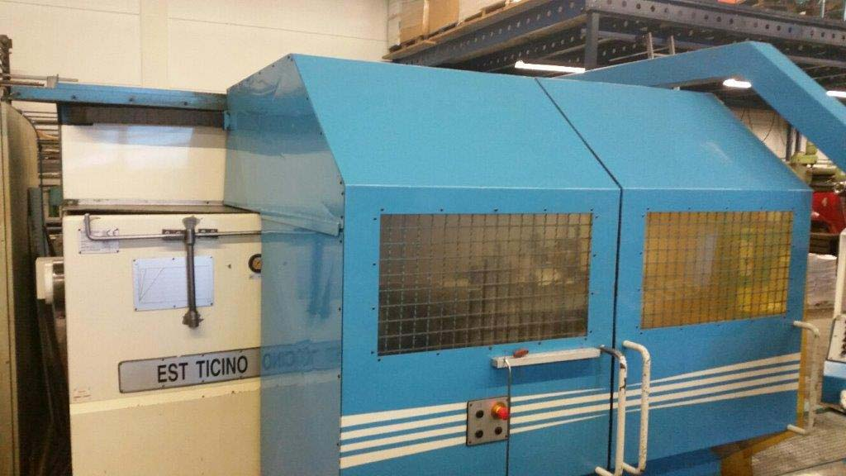
- Diameter tailstock spindle : 130
- Travel Manuel quill : 300
- Morse taper : Mk-6

- Work piece weight in chuck : 3.200
- Work piece weight b. centres : 8.500

Please Note: The above information has been obtained to the best of our ability and belief from, and from the manufacturers where possible. It is given in good faith, but its accuracy can not be guaranteed. Accordingly, it will not form a representation or constitute contractual terms. We advise you to check any vital details!

MACH4METAL

metalworking machinery
Transito 21, 6909 DA Babberich, Netherlands
Tel. + 31 (0)316 – 247123
Fax. + 31 (0)316 - 247956
info@mach4metal.com
www.mach4metal.com
Bank No : 66.52.13.883
IBAN : NL33 INGB 0665 2138 83
BIC : INGBNL2A
VAT : NL 815393635B01

EST Ticino ET – BM – MC 520 / 1500
sliding bed universal lathe
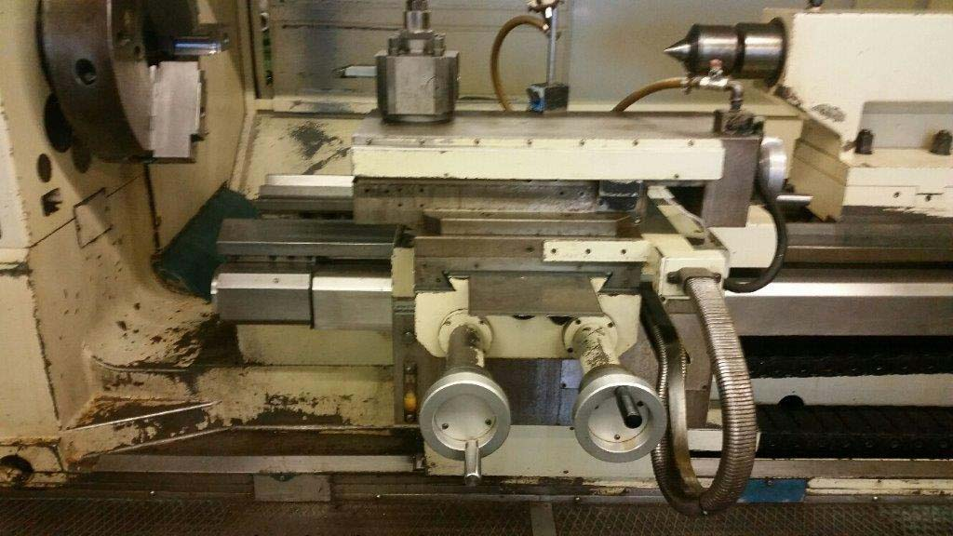
- Motor power Pk : 35
- Rapid movement X mm/min. : 4.000
- Rapid movement Z mm/min. : 2.400

- Range of spindle speeds 18 x : 6 – 600
- Max torsion moment Kgm : 1100

- Dimensions:
- Length bed “in ” : 4.000
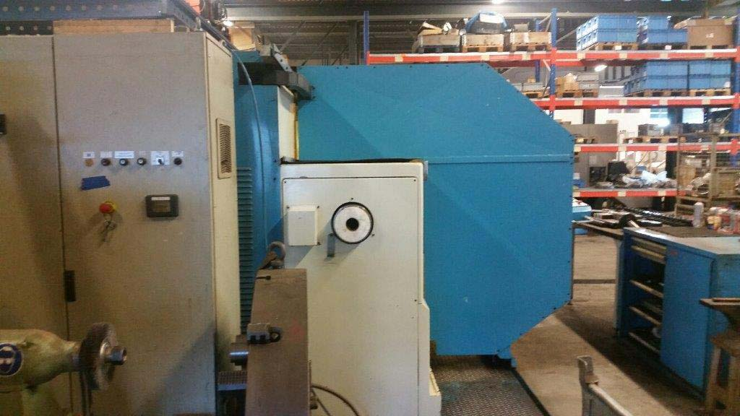
- Length bed “out” : 5.100
- Width : 2.350
- Height : 1.550
- Weight : 10.000

- Heidenhain Manuel Plus 4110
- V Constant cutting speed ?
- 3e Group speeds ?
- Z & X Axis over handwheels
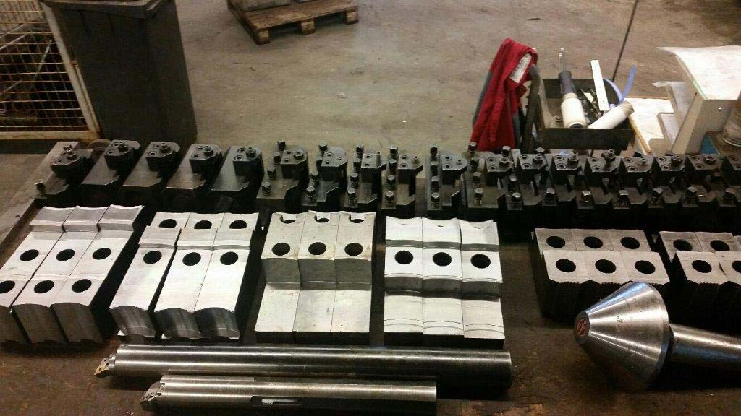
- Spindle orientation ?
- Auto cycle for;
- Threat cutting jobs
- Conical cycle

- Quick change tool system
- Build from Meehanite cast iron
- Hardened and ground guide ways
- Documentation / books

Please Note: The above information has been obtained to the best of our ability and belief from, and from the manufacturers where possible. It is given in good faith, but its accuracy can not be guaranteed. Accordingly, it will not form a representation or constitute contractual terms. We advise you to check any vital details!

